# Problem statement :

In the following social networking diagram ‘N’, we have a set of users ‘U’ who are having relationship ‘R’ between each other.

So, **N** = { U, R } where U = { Mike, Bob, .. etc } & **R** = { Bob_Mike, Mike_Emma, Emma_Liz, etc..}

For example, Mike is related to Emma, Bob and Jill where as Lisa is related to Allen

Write a program to find out the number of relationships ‘R’’ for any given user ‘U’.

***Note: Create the dataset using the following diagram. List out the assumptions as code comments***

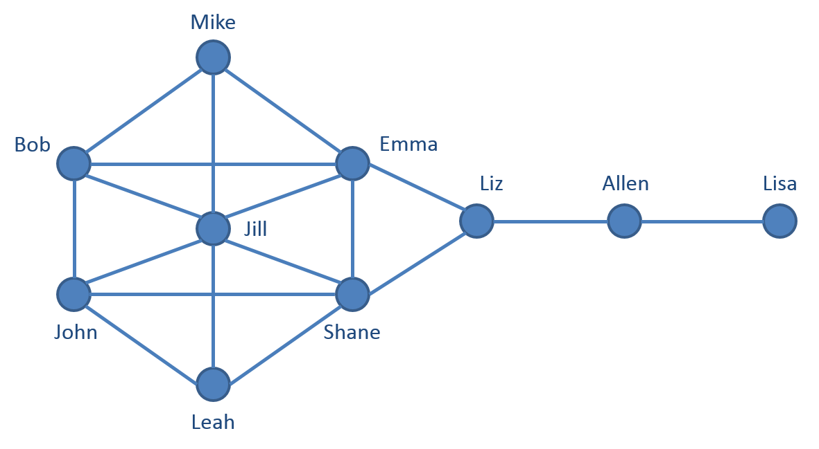

|  |
| --- |
| **Examples:**   1. Input = Leah   Output = 3 { John, Shane, Jill } |
| 1. Input = Liz   Output = 3 { Allen, Emma, Shane } |

## Instructions

* Use <https://www.jdoodle.com/compile-c-sharp-online/> as the editor to write your code.
* Remove the pre added code from line no 6 to line no 10 in the above link and code your solutions for the problem statement.
* On click of ‘Execute’, you can see the output of the code in the ‘Result’ section.
* The input can be passed as a command line arguments (string[]) to the static main method in order to check the output of the code.
* Feel free to code in any of your favourite editor (e.g. Visual Studio) and share the code file / solution to be evaluated.
* Copy the code file(s) contents from the editor (JDoodle or Visual studio) and paste it in notepad file(s). Share the notepad file(s) over email to codeathon-dotnet@globant.com